**PROJECT INTIALIZATION DOCUMENT**

**1. DETAILS**

**Team Details:** Myself Premraj Patil ([ppremraj697@gmail.com](mailto:ppremraj697@gmail.com)) only going to work on this project.

**Project Name:** Personal Portfolio Website.

**2. DEFINING PROJECT AND ITS SCOPE**

**Understanding of the project:** Nowadays it’s hard to reach out to everyone taking our Resume in our hand who is willing to hire someone as skill-full as us. An Online Portfolio Provides a Platform to Highlight our Best Work. An online portfolio is there for us to display our best work to the world on our terms. We can choose the layout of our portfolio, what pieces to show at the forefront, provide background information on every piece/project, and much more.

**Reason for choosing this project:** I choose this project as a kick-start to my development career because having an online portfolio for every working professional is a necessity nowadays, because it’s the shorthand way to showcase our current employment status, works we did in past, our educational background, experience in industry and much more to our colleagues and to the company we are aiming at.

Also, I find myself quite confident in the skillset I’m going to use to complete this project. This is the reason which boosts my confidence and motivates me to take a dig at this internship cum project opportunity.

**Most challenging aspect of the project statement:** Designing our personal portfolio is a quite challenging task because to design a portfolio which finds attractive to everybody who visits and leaves a long-lasting impression in their mind after seeing it really takes a lot effort. Adjusting each and every component on the portfolio in a way that makes sense and showcase our learnings in the best possible way is slightly challenging task. Since I like the tasks which challenges me and forces me to push my limits and put in my best work, I choose this project.

**3. APPROACH OF PROBLEM CHOSEN**

**Approach:** The approach or roadmap I’m going to follow to achieve this project is as follow.

1. I’m going to break this whole project into several small modules and going to work on them individually. And at last, I’ll configure all the components of the project.
2. Initially I’ll be designing the structure for my personal portfolio website using HTML (Hyper Text Markup Language). Using various components of HTML, I’ll decide the wireframe of my website and place different elements accordingly.
3. The second module is all about placing different sections on portfolio such as profile picture, work experience, education details, resume, certifications, projects and everything other thing that makes a perfect portfolio.
4. In next module I’ll be adding more colours and design to my personal portfolio website using CSS (Cascading Style Sheets). In this module I’ll also take care of responsiveness of website. Animation and related work will also be handled in the same module.
5. This module is probably going to be the one in which I’ll be adding some JavaScript to my personal portfolio website. JavaScript is commonly used for creating web pages. It allows us to add dynamic behaviour to the webpage and add special effects to the webpage.

**Diagram/Flowchart (if possible):**

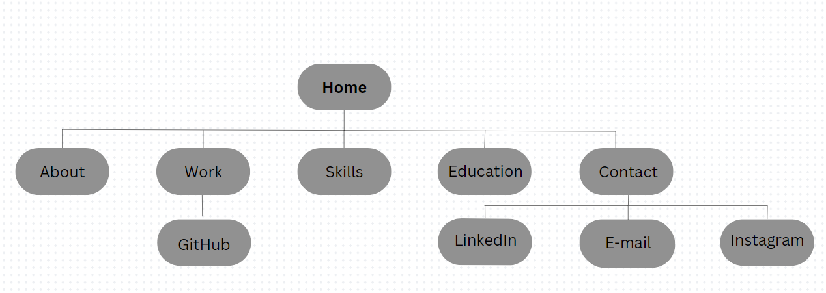

**Platform/Coding Language/Frameworks (if using):** HTML, CSS, JavaScript, Visual Studio Code

**Database/Cloud/Hosting (if using):** Netlify, GitHub

**External tools (if using):** None

**4. TEAMS ABILITY TO IMPLEMENT WINNING SOLUTION**

**Background of team members/individual:** I’m Premraj Patil currently pursuing BE in Computer Science. I’m Tech enthusiast and aiming to become a full-stack developer. I am also interested in Problem Solving and related coding stuff.

**Major Expertise of team members/individual:** Currently I have my expertise in developing user friendly webpages and interfaces. Also, I’m capable of making responsive web design using various technologies and frameworks.

**Roles and responsibilities of team members/individual:** Since I have no teammates, I am going work on each and every aspect of the project right from the start to the end. I will be doing all the stuff by breaking it into modules. Various modules include wireframe, HTML for structure, CSS for web design and JavaScript for responsiveness.

**Previous projects undertaken:** Since I’m kickstarting my development career I don’t have enough of previous industry experience. Although I did some basic projects that are the tasks to complete the certification.

**Team/Individual strengths:** I’ve interest in developing responsive web pages using my creative abilities and number of development technologies is my strength.

**Team/Individual achievements:**

**Personal motivation:** Since we’re evolving as a Computer Science Engineer and future belongs to us, we should be capable of showcasing our skills using creative abilities that resides within us. Implementing what I learn as a student is my biggest motivation and it is continuously motivating me work with tech firm like VIEH Group.